Level-6

Final Project

“Rent a Car”

By

Arshdeep Singh

Table of Contents

Project Proposal 3

Goals and Objectives 3

Project Scope 3

Project Deliverables 3

Project Specifications 3

Target Audience 4

Project Tasks and Milestones 4

Resource Requirements 5

Project Risks 5

Software Project Report 6

Analysis 6

Requirements Analysis 6

Detail Design 7

Home Page 7

Registration Page 7

Login Page 8

Admin Student Page 8

Admin Enrolment Page 8

Admin Course Page 8

Student Home Page 8

Project Testing 9

System Usability Testing 9

Testing 9

User Manual 11

Quick Setup Guide 11

User Setup 11

Admin Setup 11

General Information 11

System Overview 11

System Summary 11

System Configuration 11

User Access Levels 11

# Project Proposal

## Goals and Objectives

The goal of this project is to implement an online web app of “Rent a car”. This web app consists of admin and user. Admin can add, delete, and update cars, customers, and can-do booking. He/she can update and delete the bookings. Moreover, users can see the cars that are available for rent and the booked ones as well. Also, users can book a car for rent.

## Project Scope

This is a 20 days project in which I have implemented an online web application named “Rent a Car”. The scope of this project is to help people to rent a car easily and effortlessly.

## Project Deliverables

The following table states the deliverables for the project:

|  |  |
| --- | --- |
| **Deliverable** | **Description** |
| Final Report | Introduces the plan and elaborates on the specifications and criteria, as well as presents the goal, timeline, code, and other important details. |
| Coding | This will be the project's executable code. |
| Documentation | This will demonstrate how the web application can be used. |
| Testing | This will provide the project's test details |

## Project Specifications

* Add, delete, and update cars.
* Admin can update and delete bookings
* Add, update and delete of customer by the admin
* Users can view all available cars for rent and also the booked cars.
* Users can book a car for rent.

## Target Audience

* People who love traveling and wants to rent a car to travel around on road trip can be aged from 18 to 100 plus.

## Project Tasks and Milestones

Here are the tasks and milestones of the project:

|  |  |  |  |  |  |  |  |  |  |  |  |  |  |  |  |
| --- | --- | --- | --- | --- | --- | --- | --- | --- | --- | --- | --- | --- | --- | --- | --- |
| **Stages** | **Activities** | **Week1-2** | | | | **Week-2-3** | | | | | **Week-3-4** | | | | |
| Planning | **Technological analysis and brainstorming** |  |  |  |  |  |  |  |  |  |  |  |  |  |  |
| **Initial Meeting** |  |  |  |  |  |  |  |  |  |  |  |  |  |  |
| **Project Proposal** |  |  |  |  |  |  |  |  |  |  |  |  |  |  |
| **Proposal Documentation** |  |  |  |  |  |  |  |  |  |  |  |  |  |  |
| Implementation | **Database Design** |  |  |  |  |  |  |  |  |  |  |  |  |  |  |
| **UI Design** |  |  |  |  |  |  |  |  |  |  |  |  |  |  |
| **Identity Framework Implementation** |  |  |  |  |  |  |  |  |  |  |  |  |  |  |
| **UI Implementation** |  |  |  |  |  |  |  |  |  |  |  |  |  |  |
| **Admin Interface Implementation** |  |  |  |  |  |  |  |  |  |  |  |  |  |  |
| **User interface Implementation** |  |  |  |  |  |  |  |  |  |  |  |  |  |  |
| **Testing** |  |  |  |  |  |  |  |  |  |  |  |  |  |  |
| Closing | **Final Documentation** |  |  |  |  |  |  |  |  |  |  |  |  |  |  |

## Resource Requirements

Following technologies and development method:

* Asp.net MVC Framework
* Identity framework- ASP
* Windows Operating System
* 64-bit processor and 8 GB or more RAM

## Project Risks

The following are the high risks which could affect the execution and progress of the project:

* Project delays can lead to chain delays for other related tasks.
* The plan can be underestimated in size and length.
* For the project with confidential information, exceptional application protection must be given.
* The full required features can prevail over the time available from the developer.

|  | **Low (Yes)** | | | | **RISK** | | | | **(No) High** | | | |
| --- | --- | --- | --- | --- | --- | --- | --- | --- | --- | --- | --- | --- |
| 0 | 1 | 2 | 3 | | 4 | 5 | 6 | | 7 | 8 | 9 |
| **Inherent Risks** |  |  |  |  | |  |  |  | |  |  |  |
| **Project Objectives** |  |  |  |  | |  |  |  | |  |  |  |
| Is it a small project? |  |  |  |  | |  |  |  | |  |  |  |
| Is the plan less important for the company? |  |  |  |  | |  |  |  | |  |  |  |
| Does the plan work in advance? |  |  |  |  | |  |  |  | |  |  |  |
| Is the topic well documented? |  |  |  |  | |  |  |  | |  |  |  |
| **User Organisation** |  |  |  |  | |  |  |  | |  |  |  |
| Does the project maintain current customer procedures? |  |  |  |  | |  |  |  | |  |  |  |
| Is any additional organizational change unlikely during the project? |  |  |  |  | |  |  |  | |  |  |  |
| **Technology** |  |  |  |  | |  |  |  | |  |  |  |
| Will hardware be used? |  |  |  |  | |  |  |  | |  |  |  |
| Is it possible to avoid programming? |  |  |  |  | |  |  |  | |  |  |  |
| Is the project technically advanced? |  |  |  |  | |  |  |  | |  |  |  |
| Does existing data quality work? |  |  |  |  | |  |  |  | |  |  |  |
| **Acquired Risks** |  |  |  |  | |  |  |  | |  |  |  |
| **Scope and Goal** |  |  |  |  | |  |  |  | |  |  |  |
| Is the scope of the project well established and well agreed? |  |  |  |  | |  |  |  | |  |  |  |
| Is the project objective well defined and agreed upon? |  |  |  |  | |  |  |  | |  |  |  |
| **Project Organisation** |  |  |  |  | |  |  |  | |  |  |  |
| Are users engaged in the project? |  |  |  |  | |  |  |  | |  |  |  |
| Are the skills required? |  |  |  |  | |  |  |  | |  |  |  |
| Do all team members have a backup? |  |  |  |  | |  |  |  | |  |  |  |
| Is the project independent from a third party? |  |  |  |  | |  |  |  | |  |  |  |
| Can a small group accomplish design? |  |  |  |  | |  |  |  | |  |  |  |
| **Experience, Training and Support** |  |  |  |  | |  |  |  | |  |  |  |
| Is the technology known to the IT department? |  |  |  |  | |  |  |  | |  |  |  |
| Are users familiar with code? |  |  |  |  | |  |  |  | |  |  |  |
| Is the software provided well? |  |  |  |  | |  |  |  | |  |  |  |

# Software Project Report

## Analysis

### Requirements Analysis

#### Functional

The functional requirements of this project are divided into types. One for Admin, and one for the student.

|  |  |
| --- | --- |
| **Users** | **Functional Requirements** |
| **Admin** | * Add car, delete car, update car. * Update and delete customer. * Update and delete bookings. |
| **User** | * Can view the available cars and those are rent outed or booked. * Can book a car for rent. |

#### Non-Functional

|  |  |
| --- | --- |
| **Operational** | * The app should be able to run on all browsers and devices. |
| **Performance** | * Aiming to have a 99% performance uptime. |
| **Security** | * Only Admin has full access to the system. |

## Detail Design

### Home Page

This is the main landing page of the application. This page contains 5 main navigation buttons – Our cars, Signup, login, register as Superuser, and book your car now.

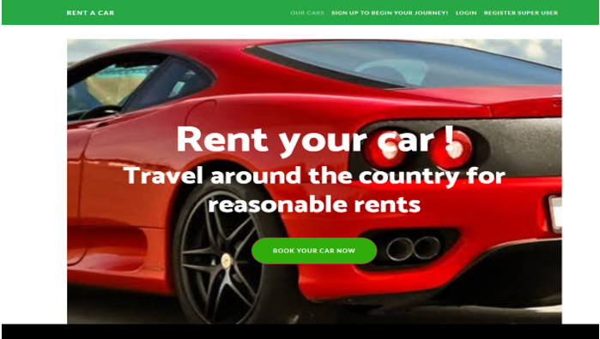

### Registration Page

An Admin can register another admin by using the register page.

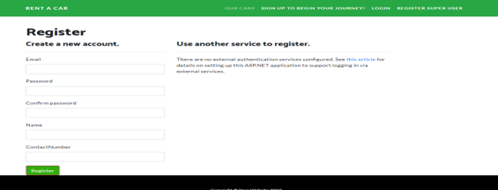

### Login Page

With the help of this page, admin and user can login to the application by using their credentials.

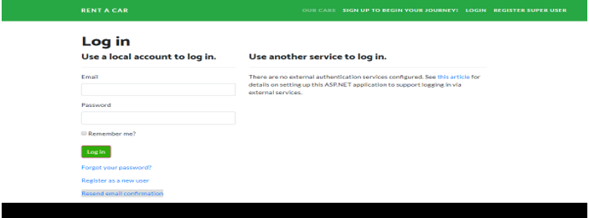

### Admin Car Page

With the help of this page, admin can edit, delete, and view the details of the cars. Also, he/she can add a new car.

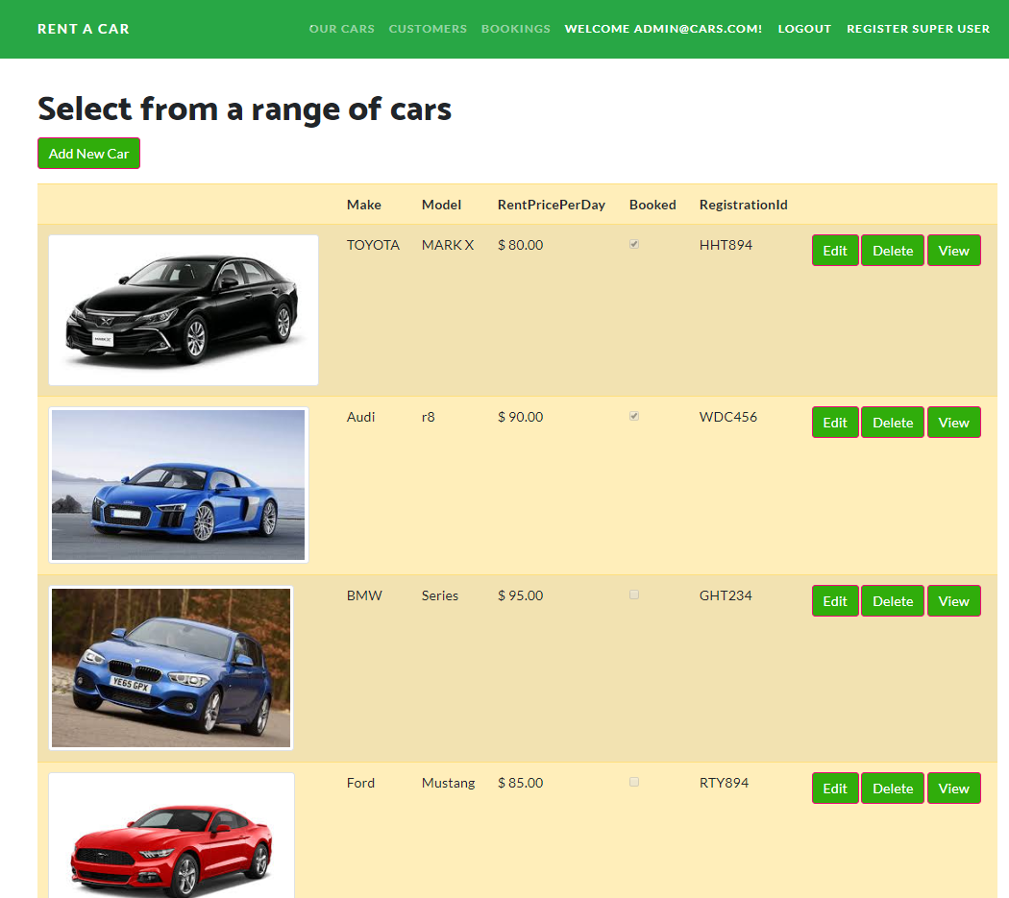

### Admin Booking Page

With the help of this page, admin can edit, delete, and view details of the booking.

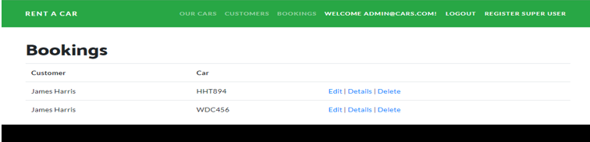

### Admin Customer Detail Page

This page will show the rights of admin on customers. An admin can edit, delete, and see the details of the customers.

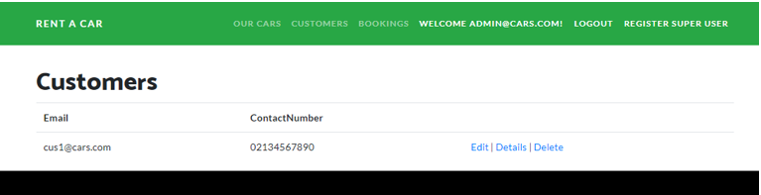

### Customer Car Page

With the help of this page, registered customers can view the available cars for rent and the ones that are already booked.

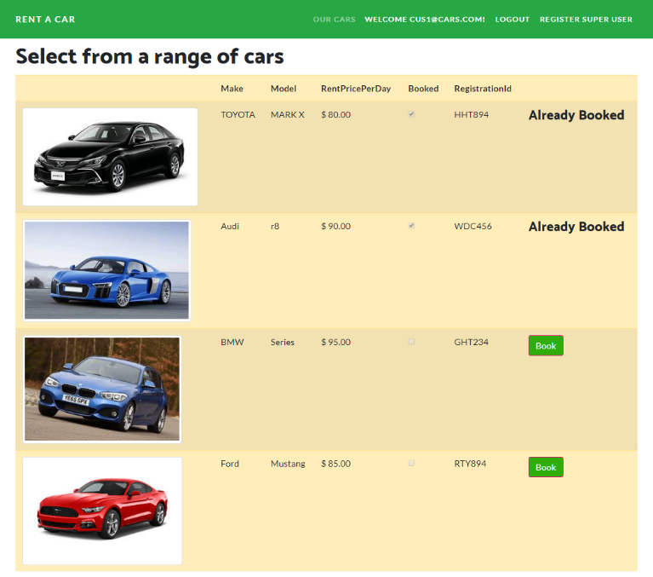

### Customer Booking Page

This page will highlight the option using that a registered user can complete the booking to rent a car.

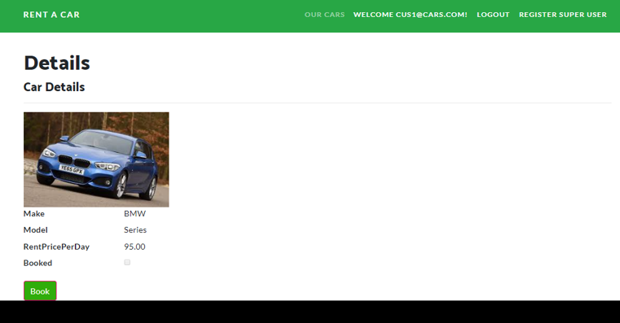

# Project Testing

## System Usability Testing

### Testing

**Tester 1**

|  |  |  |  |  |  |
| --- | --- | --- | --- | --- | --- |
| **Tester – 1** | | **Scale** | | | |
| **No.** | **Question** | **Strongly Agree** | **Agree** | **Neutral** | **Disagree** |
| 1 | I think that I would like to use this application more frequently |  |  |  |  |
| 2 | I found the system complicated |  |  |  |  |
| 3 | Is the system easy to use? |  |  |  |  |
| 4 | Do you think you need the support of a technical person to use this system? |  |  |  |  |
| 5 | All functions of the system were well-integrated |  |  |  |  |
| 6 | Did you find any inconsistencies in this system |  |  |  |  |
| 7 | I think most people would learn to use this system very quickly |  |  |  |  |
| 8 | I found the system very challenging to use |  |  |  |  |
| 9 | I felt very confident using the system |  |  |  |  |
| 10 | I needed to learn a lot of things before using the system |  |  |  |  |

**Tester 2**

|  |  |  |  |  |  |
| --- | --- | --- | --- | --- | --- |
| **Tester -2** | | **Scale** | | | |
| **No.** | **Question** | **Strongly Agree** | **Agree** | **Neutral** | **Disagree** |
| 1 | I think that I would like to use this application more frequently |  |  |  |  |
| 2 | I found the system complicated |  |  |  |  |
| 3 | Is the system easy to use? |  |  |  |  |
| 4 | Do you think you need the support of a technical person to use this system? |  |  |  |  |
| 5 | All functions of the system were well-integrated |  |  |  |  |
| 6 | Did you find any inconsistencies in this system |  |  |  |  |
| 7 | I think most people would learn to use this system very quickly |  |  |  |  |
| 8 | I found the system very challenging to use |  |  |  |  |
| 9 | I felt very confident using the system |  |  |  |  |
| 10 | I needed to learn a lot of things before using the system |  |  |  |  |

# User Manual

## Quick Setup Guide

### User Setup

There is no need for a separate setup for the intended customers as a web application, but registrations are accessible via the website. You can access the web application

via local hosting.

### Admin Setup

#### Admin is responsible for managing care, customer and booking for the cars

## General Information

### System Overview

Rent a Car is an online app. This web app consists of admin and user. Admin can add, delete, and update cars, customers, and can-do booking. He/she can update and delete the bookings. Moreover, users can see the cars that are available for rent and the booked ones as well. Also, users can book a car for rent.

## System Summary

### System Configuration

Rent a Car is a web application developed using Asp.net MVC Framework. It works on most modern web browsers and does not need a special program setup. Internet access is required as a web application.

### User Access Levels

Only registered customers can access the features of Rent a Car web application.

**Admin:** Full access to the cars, bookings and customer details

**User:** Limited access can only see the available car and booked cars and can book a car for rent.